



THE ULTIMATE CSS GUIDE

Author: Anil Solanki  
Date: 14 Sept 2025

Hello, HTML stands for Hypertext Markup Language ✔️

Heading arial H1

Heading arial H2

monospace consol

Special Note:

Hello

Html

CSS: Cascading Style Sheets

What is CSS

**Cascading Style Sheets** (**CSS**) is a stylesheet language used to describe the presentation of a document written in HTML or XML. CSS is among the core languages of the **open web** and is standardized across Web browsers.

CSS (Cascading Style Sheets) is used to style and layout web pages.

Browser Default Styles

HTML elements have default styling, which are default CSS stylesheets stored in browser, these default styles make different level of headings ( <h1> to <h6> ) look bold, and big then regular text and each have different size, links are coloured and underlined, <div> takes full width (block element), and <span> takes content fit width (inline element).

These default styling applied by browser to make sure the page is readable even if developer don’t have applied any CSS explicitly.

What is CSS for?

CSS controls how HTML elements look in web browsers.

* A document is usually a text-file structured using a markup-language like HTML Document, SVG (Scalable Vector Graphics), or XML.
* HTML document is a text-file which contains the content of webpage and specify the structure of webpage.
* HTML doc can be viewed in two ways
  + Opening in text-editor or code editor, in which we can edit the content of html document.
  + Opening web page into browser by this we can see the output of HTML document, means the actual webpage. Browser render the HTML document to show us the output webpage.
* The CSS language is organized into *modules* that contain related functionality.

CSS Syntax Basics

CSS is a Rule based language; means we define rules in which we write properties and their respective value and selector for element or group of elements on which we want to apply style.

Eg. To apply CSS on <h1> element of our webpage, we can achieve this like:

h1 {

color: red;

font-size: 2.5em;

}

Here:

* CSS Rule start with selector, this is a **Tag selector** or **Element selector** in which we only write name of tag, here the h1 element(s) get selected.
* Then there are curly braces { } , in these curly opening and closing brace we write CSS declaration(s). Each declaration contains a property and a value.
* In above example, color is property, red is value of color property and this statement color: red; is called a CSS declaration.
* The block of declarations, i.e. { declaration(s) } is called Declaration Block.

This is the syntax of every CSS Rule:

selector {

property1: value1; /* first declaration*/

property2: value2; /* second declaration */

……

PropertyN: valueN; /* Nth declaration */

}

Adding CSS to our Webpage

External Stylesheets

Writing CSS in a separate file with a .css extension and then link that .css stylesheet file to HTML document, we can link many stylesheets to one Html doc, and one stylesheet to many Html documents.

This is how we link styles.css to index.html

<link rel="stylesheet" href="styles.css" />

<link> element is used to link external document to html document, rel attribute specifies that the linking file is a stylesheet, and href attribute stores the path of stylesheet file.

Internal Stylesheet

Internal stylesheet is like external stylesheet, but it’s written inside html document in the <style> element, and this <style> element is written inside <head> element. E.g.

<head>

<style>

    p {

        background-color: *brown*;

      }

</style>

</head>

For sites with more than one-page, internal stylesheets are less efficient than external stylesheets.

Inline CSS

This styling only applies on the single element on which it is applied, in this CSS the declarations are stored inside the style attribute in the element. E.g.

<span style="color: purple; font-weight: bold">span element</span>

**Avoid using CSS in this way if possible.** It is a bad practice.

Common Selectors (You must know)

We can select HTML same tag element(s) by Element selector / Tag selector / Type selector. For e.g. to select all paragraph elements of html doc, we can

P {

Color: red;

}

We can target multiple different type of elements at one CSS rule and apply same style on them by separating selectors by commas ( , ) ; Like

table, tr, td, th {

border: 2px solid black;

}

The above rule will apply all the declarations of declaration block on each <table>, <tr>, <td>, and <th> tags.

We can select element using class name, selector is .className

For

<p class="my-para">This is my paragraph</p>

CSS style can be applied using class selector as

.my-para {

color: red;

font-size: 30px;

}

Descendant selector, using this we can select elements based on their location in DOM tree, like e.g. selecting the <span> which is child of <p> tag, and these <p> tags should be a child of a <div> tag, and colouring background of <span> tags as aqua. Here we use Descendant selector / Descendant combinator.

span p span {

background-color: aqua;

}

We also have **next sibling combinator** which we can use to select an element which we can use to select an element which comes after another specified element in the

same hierarchy, so if we want to select each <p> (paragraph) that comes just after an <h2> element in dame hierarchy, we can do as:

h2 + p {

color: red;

}

Styling based on state of element, we use pseudo class selectors to style element on a specific state, e.g.

a:link {

color: pink;

}

a:visited {

color: green;

}

a:hover {

text-decoration: none;

}

Other important things

Most of the CSS values are simple keywords, or numerical values, but there are some values which take form of a function.

calc( ) function : This calc( ) function used to calculate things automatically, in the above example width of the element becomes, width= 90% of the parent width - 30px.

width: calc(90% - 30px);

rotate( ) function: This function rotates the element

transform: rotate(0.8turn);

@rules: (pronounced "at-rules") provide instructions for how CSS should behave. One most common is @media query rules, which is used to define when the css should get applied to the webpage. E.g. @media (width >= 30em) { ….} applies the css to html doc when the width of element is greater or equal to 30em, means 30 * (width of parent container).

@media (width >= 30em)

{

body {

background-color: blue;

}

}

Shorthand properties: These are properties that are combination of other related properties and create a shorthand property. Eg1.

padding: 10px 15px 15px 5px;

Is same as

padding-top: 10px;

padding-right: 15px;

padding-bottom: 15px;

padding-left: 5px;

E.g2.

background: red url("bg-graphic.png") 10px 10px repeat-x fixed;

Is same as

background-color: red;

background-image: url("bg-graphic.png");

background-position: 10px 10px;

background-repeat: repeat-x;

background-attachment: fixed;

CSS Comments

As with any coding work, it is best practice to write comments in your CSS, it helps us in future, and others to understand code.

CSS comments begin with /* and end with */. Eg.

/* Handle basic element styling */

body {

padding: 1em; /*this rule sets padding to all sides of 1em */

margin: 0 auto;

max-width: 33em; }

White space in CSS

White space means actual spaces, tabs and new lines. Just as browsers ignore extra white space in HTML, browsers ignore extra white space inside CSS. The benefit of white space is that it makes it easier for you to read the code.

* Property names never contain whitespace.
* property values that expect white space between multiple values will be invalid if that space is removed.

Basic Selectors

What is a selector?

Selector is part of CSS Rule, and it is keyword, or group of keywords that define which element(s) should be selected, and then the declaration block styles should get applied to them.

The Elements selected by selector are termed as 'Subject of Selector'

Type/Tag/Element Selector

This selector selects all the tags/elements of the HTML doc with the specified tag in the selector.

Eg1. p {…….} , will select all <p> tags of the html page.

Eg2. div {………}, will select all <div> tags of the html page.

Class Selector

Class selector starts with a dot ( . ) then the class name of element(s). It will select all element(s) having the specified class. Eg. For styling h1 and p together we gave both same class="highlight",

<h1 class="highlight">Class selectors</h1>

<p class="highlight"> Gumbo beet greens corn Soko gumbo gourd. </p>

Styles can be applied to both together by using their common class, such as

.highlight {

background-color: yellow;

}

Targeting Particular Element using Class

Eg. If a <span> and <h1> both have same class="highlight", then how can we select each of them separately?

We use Combining selector for such case, syntax of such selector starts with its tag name then .class then #id then attribute can also be added.

Eg.

<h1 class="highlight">Class selectors</h1>

<span class="highlight">kohlrabi Welsh onion</span>

<span>Lorem ipsum demor itua</span>

We can select <span> with class="highlight" by this way

span.higlight {

background-color: yellow;

}

Selecting Element which have Multiple Classes

Again, we use Selector combinations

<div class="notebox">This is an informational note.</div>

<div class="notebox warning">This note shows a warning.</div>

<div class="notebox danger">This note shows danger!</div>

CSS can be applied to second and third <div> separately like:

.notebook.warning {

color: red;

}

.notebook.danger {

Color: yellow;

}

Id Selector

Id selector begins with # and then id name. One Id value can only be given to one element per webpage. So, Id is unique.

Eg.

<h1 id="heading">ID selector</h1>

<p id="one"> Gumbo beet greens corn soko.</p>

CSS can be applied as

#heading {

background-color: yellow;

}

p#one {

color: rebeccapurple;

}

Multiple selector

Table, p, h1, div {

Color: red;

}

Universal Selector

The universal selector is indicated by an asterisk (*). It selects everything in the document. Eg.

* {

margin: 0;

}

More use of Universal selector

Eg. If we want to select all the first child elements of any descendants of <article> element. We can do this by

article :first-child {

font-weight: bold;

}

But this will be confused with article:first-child, which selects all <article> elements which are first child of there parent.

So basically, if **x:first-child** is the selector then every **x** element which is first-child of its parent.

To avoid this confusion we write the selector, as

article *:first-child {

font-weight: bold;

}

Combinators

Descendant Combinators

It selects the element based on its parent, parent or grand-parent, or great-grand-parent element of an element are generally called the ancestors of child. This selector is also known as called **descendant selectors**. Eg.

body article p {

color:red;

}

Child Combinator

Here a > sign is placed between parent and child; it is used to select the direct child(s) of parent.

article > p {

/* … */

}

Next Sibling Combinator

Here we use + and, Eg. h1 + p { }

In the example, all the elements <p> will be selected when it is next-sibling of an <h1> element,

h1 + p {

background-color: #333333;

color: white;

}

Subsequent Combinator

To select the element(s) when they are present anywhere after another element, in the same hierarchy.

h1 ~ p {

background-color: #333333;

color: white;

}

Combining Combinators

ul > li[class="a"] {

}

Attribute Selector

Attribute Presence Selector

If we want to select all elements that have an attribute, whatever value it may have, it only should be present in the element's opening tag, we can select them in this way:

Eg. For

<ul>

<li>Item 1</li>

<li class="a">Item 2</li>

<li class="a b">Item 3</li>

<li class="ab">Item 4</li>

<li class="a-b">Item 5</li>

<li class="a-cde">Item 6</li>

</ul>

We can select above element or elements having this attribute as

li[class] {

color: red;

}

This will select 2nd, 3rd , and 4th <li> elements

Attribute Value Selector

To select elements with an attribute, that too having a specified value. We can do this in three different ways:

Eg.

* To select element(s) having exact same attribute value of an attribute.

li[class="a"]

This will select only the 2nd <li> element.

* To Select element(s) having one value of attribute same as specified, (it is used when attribute have value having white spaces.).

li[class~="a"]

It will select 2nd, and 3rd list item.

* To select element(s) having attribute whose value start with a specified value and then followed by hyphen and then may have other values.

li[class|="a"]

It will select only the 5th and 6th list item element, as 5th and 6th element's class="a-b" ; class="a-cde", here class value start with a, and a is followed by hyphen thus these element's get selected.

Substring Matching Selector

These selectors allow for more advanced matching of substring inside the value of attribute.

Eg. To select elements having these classes **box-warning**, **box-error**; we need to select elements whose class value start with box-, for this purpose we can use

[class^="box-"] , or [class|="box"].

More substring matching selectors,

Eg.

<ul>

<li class="a">Item 1</li>

<li class="box-error">Item 2</li>

<li class="box-warning">Item 3</li>

<li class="bcabc-box">Item 4</li>

</ul>

* Selecting element(s) whose attribute value start with specified value.

li[class^="box-"]

This will select 2nd and 3rd list items.

* Selecting element(s) whose attribute values ends with a specified value.

li[class$="-box"]

This will select 4th list item.

* Selecting element(s) having attribute values anywhere in the attribute value string.

li[class*="box"]

This will select 2nd, 3rd, and 4th list items.

Pseudo-classes and pseudo-elements

What is a pseudo-class

A pseudo-class is a selector that selects elements that are in a specific state.

* This will select and apply CSS rule to element when mouse is hovering over the element.

selector:hover

* This will select the element who is subject of selector, only if it is first child of its parent container.

Selector:first-child

* Some link controls like text-decoration etc, are controlled using :link pseudo class.

a:link

* Some link controls like color etc. are controlled by :visited pseudo class.

a:visited

There are some more

* :active -> select and style element when it is clicked.
* :focus -> when input field is focused.
* :focus-visible -> when focus is through keyboard not mouse.
* :focus-within -> when element or any of its child is in focus.
* :link -> Select and style unvisited links.
* :visited -> style visited links.
* :any-link -> Select link whether it is visited or not.
* :first-child -> Selects element when it is first child of its parent.
* :only-child -> when the element is only child of its parent.
* :nth-child(n) -> Select element only if its nth child of its parent. n can be 1, 2 ..etc.
* :nth-last-child(n) -> Select element only if its nth child of its parent from last.
* :enabled -> style input field if its enabled.
* :disabled -> style input field when it is disabled.
* :checked -> style of checkbox or radio when it is checked.
* :valid -> style if input value is valid
* :invalid -> style if input value is invalid.
* :has() -> select parent if the child specified in ( ) is present in the parent.
* :playing -> when media is playing.
* :paused -> when media is paused.

Pseudo Element

Pseudo elements are special keywords of CSS which allow us to style specific part of an element, without wrapping that part in separate element.

Eg. If we want to bold the first line of paragraph, one may think that let's wrap first line into <span> and then add font-wight: bold; to it, but when the screen width changes the width will contain fewer words then previous, and thus our aim to only bold first line will get destroyed. So here pseudo element becomes useful. Pseudo elements double colon ( :: ) se start hote hai. Eg.

p::first-line {

font-weight: bold;

}

There are more such pseudo elements like:-

* ::first-letter -> Only style first element

p::first-letter {

font-size: 2em;

}

* ::before -> add new virtual content before the elements content. Without changing HTML. Eg.

p::before {

content: "👉 ";

}

* ::after -> Add new virtual content after elements content.

p::after {

content: " ✅";

}

* ::selection -> This style is added to the selected text, when user select the text.

p::selection {

background: yellow;

}

Some more less used-

* ::marker -> Used to style the listing bullets or numbers styling.
* ::placeholder -> used to style the placeholder text.
* ::backdrop -> Style the background in full screen mode, like video playing.
* ::file-selector-button -> Used to style the **choose file** button in <input type="file">

CSS Box Model

Block Element

* display: block;
* Each Box appears on new line.
* width & height properties can be set.
* If width is not specified then it will take 100% width of the parent.
* Eg. <p>, <div>, <h1> to <h6> etc.

Inline Element

* display: inline;
* Block will not appear on new line; they come in same line if there is space available.
* width and height properties don't work and hence cannot be set. Width is default set to content width, and height as content height.
* Eg. <a>, <img />, <span>, <em>, etc.

Inner and Outer display

* Inline and block are outer display properties; they define how the box is laid out wrt other boxes.
* We can also define how inner elements of the box is laid out. Eg. display: flex; will set the inner display property to flex, and thus all child elements/items of box become flex items and behave according to flexbox styling.

What is CSS Box Model

It defines how the different parts of a box — margin, border, padding, and content — work together to create a box of element which we see on webpage.

Parts of CSS Box Model:

* Content Box -> The actual content area, dimensions are controlled by height and width properties.
* Padding Box -> The padding sits around the content as white space, size using padding properties.
* Border Box -> The border box wraps the content and any padding; size using border properties.
* Margin Box -> The margin is the outermost layer, wrapping the content, padding, and border as whitespace between this box and other elements. Size using margin properties.

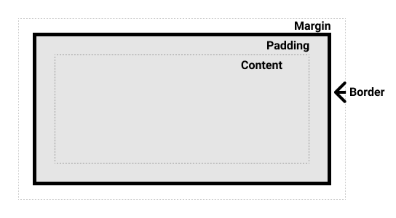

Alternative 🡪 box-sizing: border-box;

Border comes around the actual content width, and padding comes under border that push the content inwards. Thus shorting the actual content size.

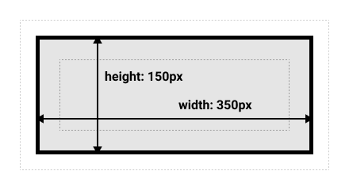

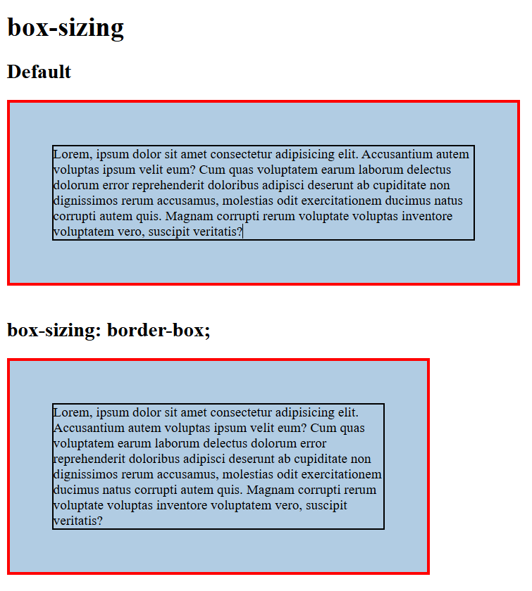

Margin

* margin-top
* margin-right
* margin-bottom
* margin-left
* margin

margin: 10px; /* sabhi 4 sides = 10px */

margin: 10px 20px;

/* top+bottom = 10px, left+right=20px */

margin: 10px 20px 30px;

/* top = 10px, left+right = 20px, bottom = 30px */

margin: 10px 20px 30px 40px;

/* top = 10px, right = 20px, bottom = 30px, left = 40px */

Important things:

* **Length units:** px | em | rem | cm | % | ...
* **Percentage (%):** relative to containing **parent container**
* **Keyword:** auto (used mostly for cantering block elements with margin: auto)

Border

* border

border: 1px;

/* width only (style default nahi lega → no visible border) */

border: 1px solid; /* width + style */

border: 1px solid black; /* width + style + color */

border: medium dashed red;

* border-top
* border-right
* border-bottom
* border-left

border-top: 2px solid blue;

border-right: 5px dashed red;

border-bottom: thick dotted green;

border-left: 1px solid black;

* border-width

border-width: thin; /* predefined */

border-width: medium; /* predefined */

border-width: thick; /* predefined */

border-width: 5px; /* custom length 5px on four all sides*/

border-width: 1px 2px; /* top+bottom = 1px, left+right = 2px */

border-width: 1px 2px 3px; /*top=1px, left+right=2px, bottom=3px */

border-width: 1px 2px 3px 4px; /* top=1px, right=2px, bottom=3px, left=4px */

* border-style

border-style: none; /* no border */

border-style: solid; /* plain solid line */

border-style: dashed; /* broken dashes */

border-style: dotted; /* small dots */

border-style: double; /* two lines */

border-style: groove; /* 3D groove */

border-style: ridge; /* 3D ridge */

border-style: inset; /* 3D inset */

border-style: outset; /* 3D outset */

border-style: solid dashed; /* top+bottom=solid, left + right = dashed */

border-style: solid dashed dotted; /* top=solid, left + right = dashed, bottom = dotted */

border-style: solid dashed dotted double; /* top, right, bottom, left */

* border-color
* border-top-width
* border-top-style
* border-top-color
* border-right-width
* border-right-style
* border-right-color
* border-bottom-width
* border-bottom-style
* border-bottom-color
* border-left-width
* border-left-style
* border-left-color

Important things

* **Width keywords:** thin | medium | thick
* **Style keywords:** none | solid | dashed | dotted | double | groove | ridge | inset | outset
* Border **visible tabhi hota hai jab border-style set ho**.

Padding

* padding
* padding-top
* padding-right
* padding-bottom
* padding-left

padding: 10px;

/* sabhi 4 sides = 10px */

padding: 10px 20px;

/* top+bottom = 10px, left+right = 20px */

padding: 10px 20px 30px;

/* top = 10px, left+right = 20px, bottom = 30px */

padding: 10px 20px 30px 40px;

/* top = 10px, right = 20px, bottom = 30px, left = 40px */

Important things:

* No auto keyword
* **Length units:** px | em | rem | cm | % ….etc.

Display inline-block

**display: inline-block** is a special value of display, which provides a middle ground between inline and block. We use it when we don’t want to get each item on new line, but also want's the width and height of element to be set and adjusted.

Handling Conflicts

Sometimes we may come across situations where we are applying a CSS property but its not working, its most probably due to conflicting styles. You may have created two rules of the same elements same property and given two different values.

To handle such conflicts CSS introduce concepts like specificity, cascade, inheritance, and !important.

Units

| Unit | Name | Equivalent to |
| --- | --- | --- |
| cm | Centimeters | 1cm = 37.8px = 25.2/64in |
| mm | Millimeters | 1mm = 1/10th of 1cm |
| Q | Quarter-millimeters | 1Q = 1/40th of 1cm |
| in | Inches | 1in = 2.54cm = 96px |
| pc | Picas | 1pc = 1/6th of 1in |
| pt | Points | 1pt = 1/72nd of 1in |
| px | Pixels | 1px = 1/96th of 1in |